**3) Search functionality of a website.**

**1. Quick calculator.**

Opening the browser and entering the keyword as tip calculator to get the quick calculator.

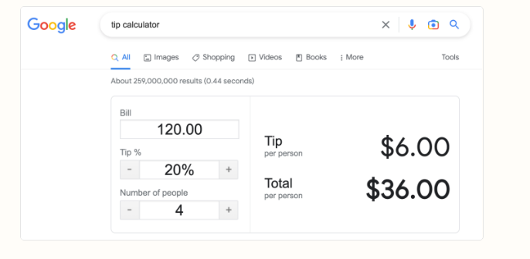

**2. Quick conversion.**

Opening the web browser and entering the keyword as quick conversion to get the quick converter.

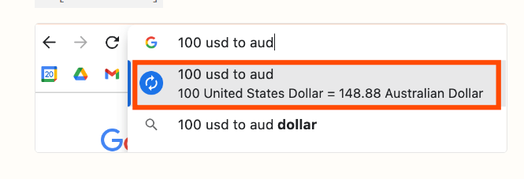

**3. Quick data conversion.**

Opening web browser and entering the keyword as quick data conversions to make the quick conversions through website.

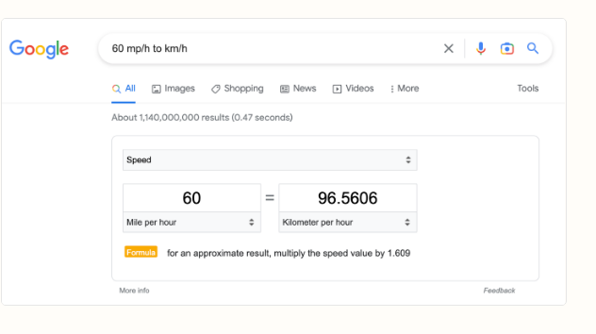

**4. Word search.**

Opening the web browser or an application and search for new words to the accurate meaning and explanations.

